MASCHERPA Audric ROB 3 2022 / 2023

**POLY-SNAKE**

**Weekly report n°14 from 28/02/23 :**

The new wheels and their supports have arrived, so the beginning of this session focused on the use of these wheels and their implementation on the 3D model.

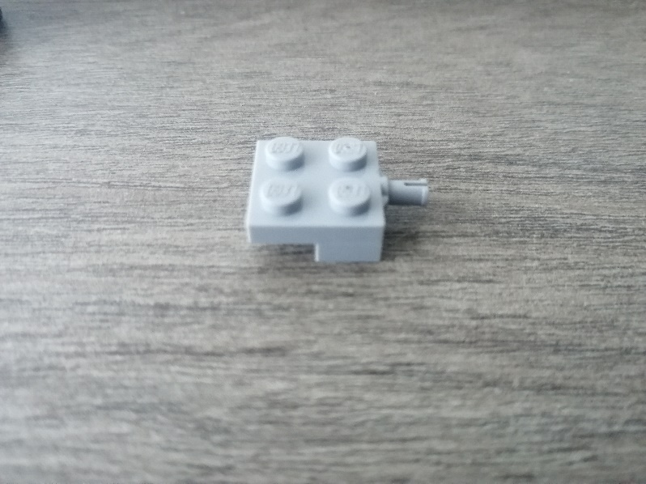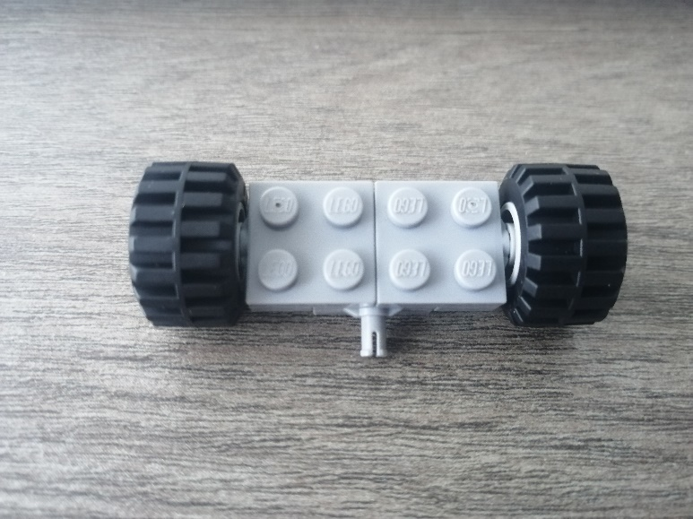The ultimate goal is to be able to use these wheels so that the snake can move forward only from the undulating movement and without any motorization. here is the arrangement of the wheels in figure 14.1.1

Figure 14.1.2

Figure 14.1.1

Figure 14.2

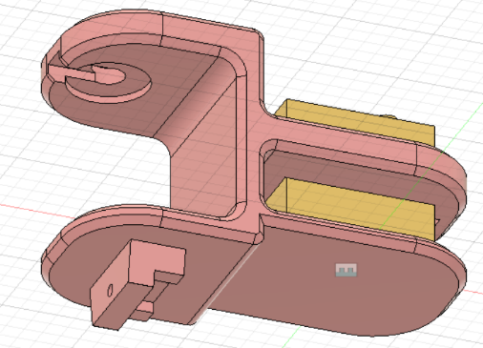

This figure is made up of 3 lego pieces 4488 (in figure 14.1.2) as well as two wheels. The objective is to be able to attach these lego pieces directly to the modules that make up the PolySnake so as not to have to use screws or nuts. We can therefore see in figure 14.2 a 3D model of the module with the area allowing the wheels to be accommodated.

Figure 14.3

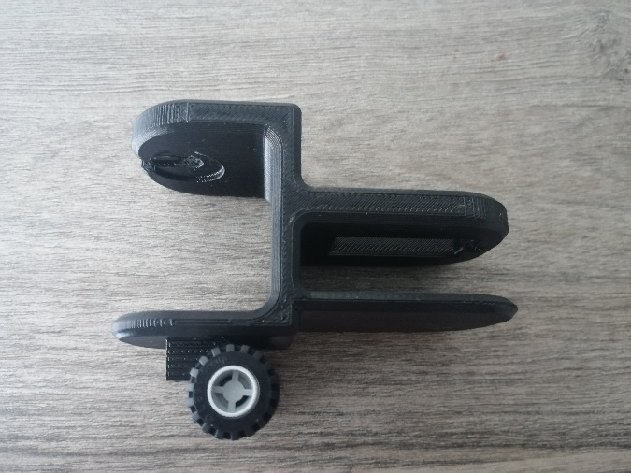

We can therefore finally see a photo of the final rendering of this model with wheels in figure 14.3.

The next session will therefore be dedicated to printing all the modules as well as the head and tail of the snake and adding the wheels to them in order to check if our program allows our project to move without motorization.